# Intercom Assignment

Name: Sean Haughey

Email Address: [seanthaughey@gmail.com](mailto:seanthaughey@gmail.com)

**Overview**

The backend application is developed in ASP.net core with RESTFUL approach.

The end-user can upload a text file to the endpoint. This textfile gets saved in a location specified in the environment setting (explained below ). Once the textfile is in the correct format the data is tranformed into a invitee record that is saved in the same location.

**Technical environment**

In order to run the solution you need to use Visual Studio 2019 (Community edition is free to download at <https://visualstudio.microsoft.com/>)

If you get the following message – “You should only open projects from a trustworthy source while opening the solution”, click OK.

Make sure you have Internet access before buiding the solution, so the Nuget packages can be downloaded.

The first step is to select the location where you are going to save the text files .

* Right click on the Intercom.Api project , then left click on the properties enviroment variables . Go to debug -> filePath and change the value to where you want to save the files.

Figure 1: Configuring system variable setting.

All exceptions are logged to a text file. To change the location of the where the log gets saved go to appsettings.json and change the path locations. See screenshot below.

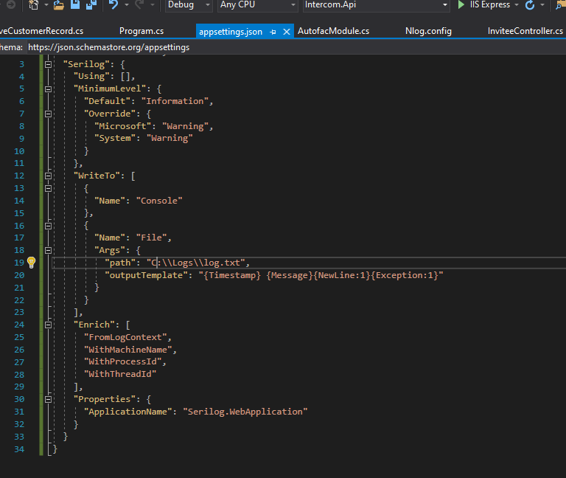

Figure : Location of where error handling logs get saved.

Once the solution is successfully built, run it by pressing F5 or clicking the Run button as in the picture below. Make sure the Intercom.Api is set as the start-up project.

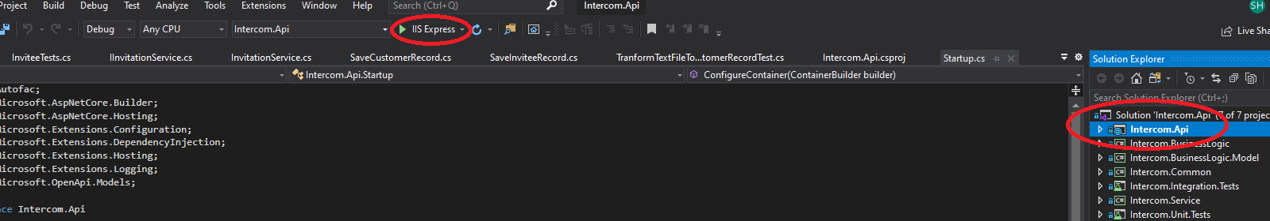

Figure 3: How to run the web application.

Once the api is running go to <https://localhost:44309/swagger/index.html> or <http://localhost:64734/swagger/index.html>.

To use the swagger click on “Try it out” . Then click the dropdown box in “Response body” and select multipart/form-data .

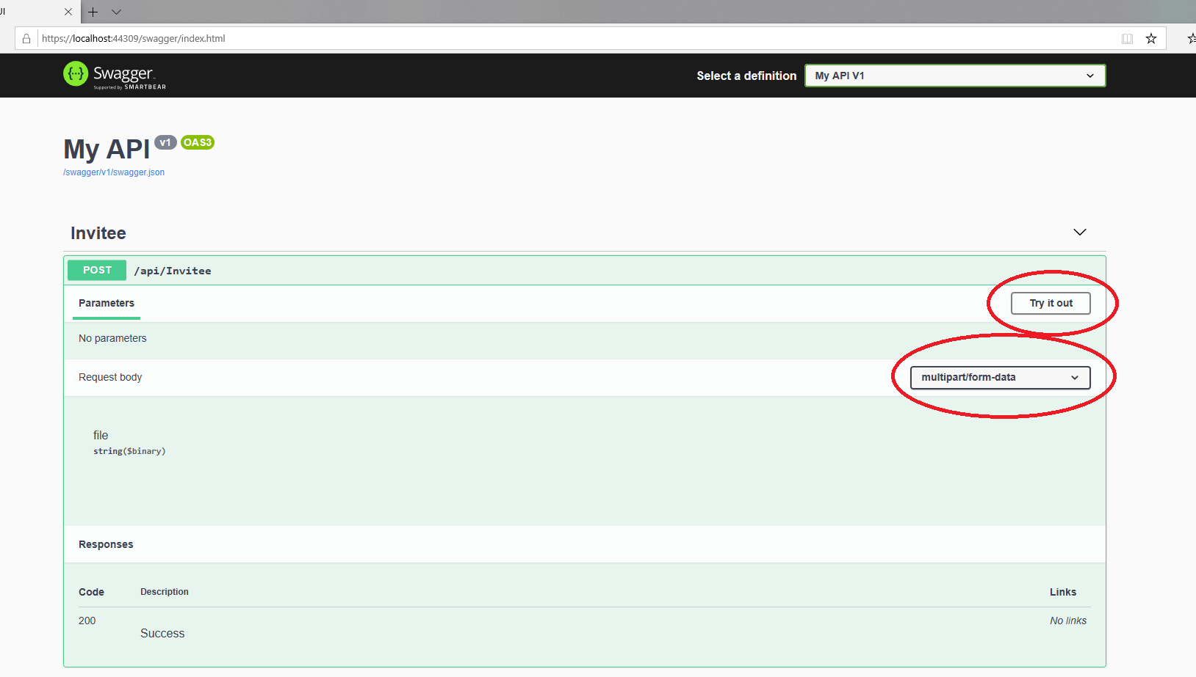

Figure 4: Swagger homepage

Next click on file and upload a customer.text file. Then click on the excute button below it.

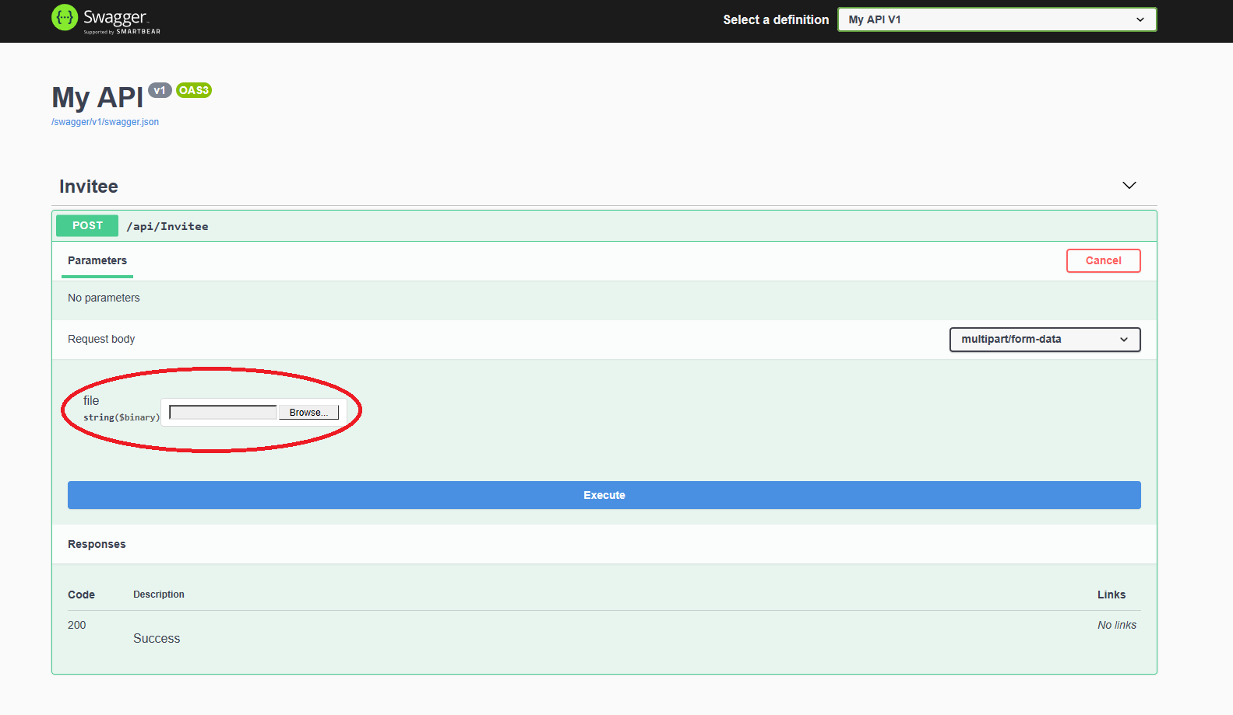

Figure 5: Uploading textfile to swagger

Once the file has been sent in the correct format you should get response similar to the one below.

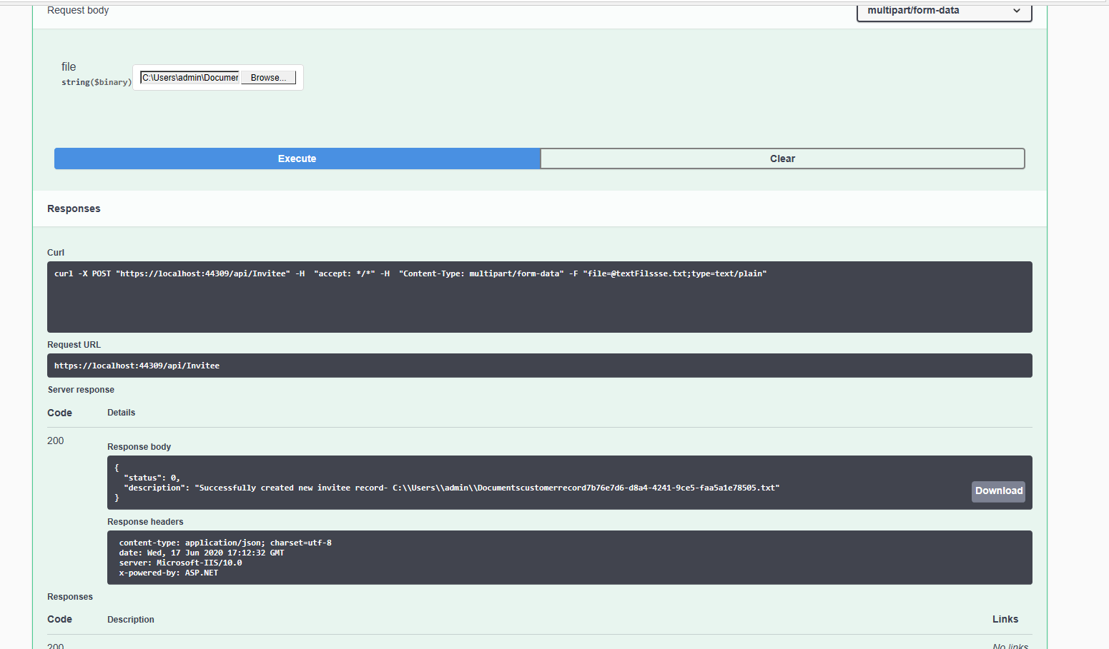

Figure 6: Successful response - gives location of where the invitee record has been saved.

# How to run the Unit Tests.

In toolbar select test –test explorer.

The test explorer window will then appear. Right click on the unit tests and select run tests.

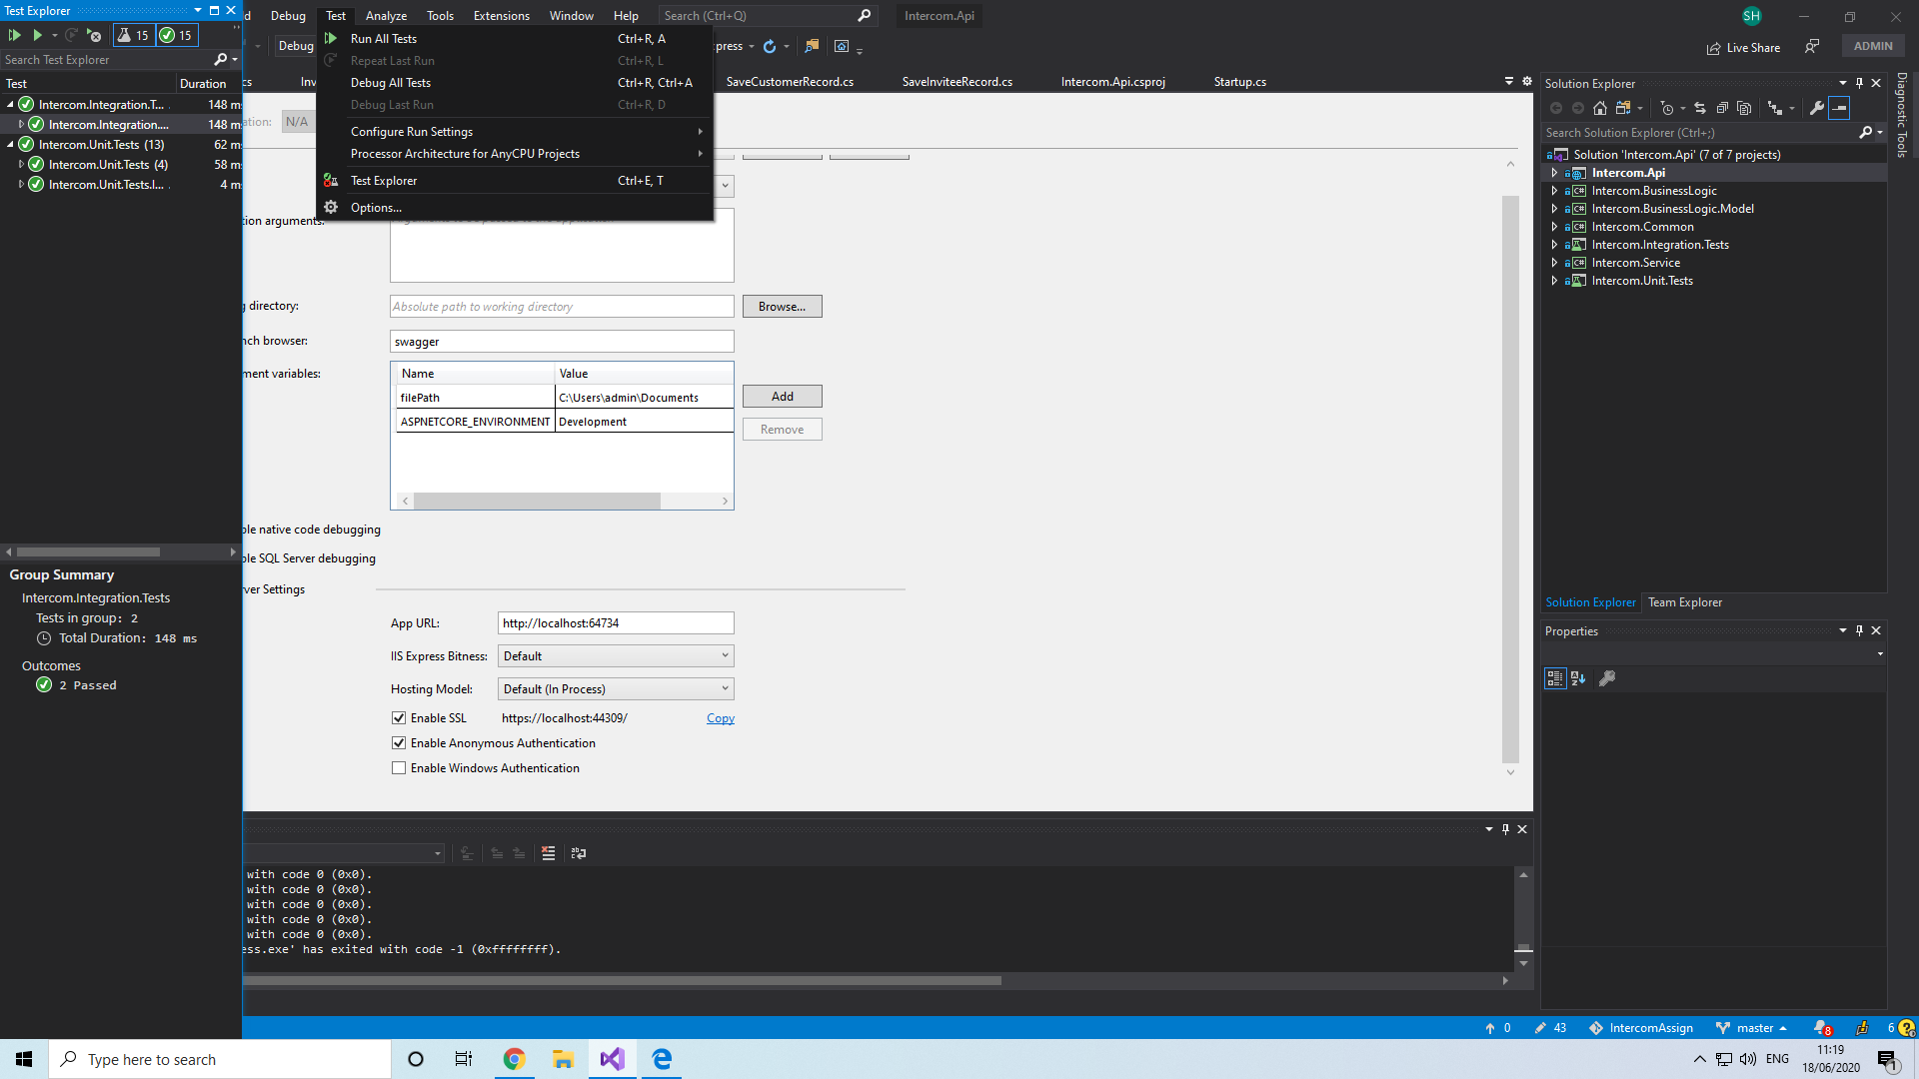

Figure : Xunit tests and Integration tests plane

# How to run the Integration Tests.

To run the integration tests an instance of the application needs to be running. Go to debug start with debugging. Then run the integration tests.

# Proudest Achievement.

The work I did in completing my research masters helped secure my college’s first commercialisation venture that led to technology transfer licencing to a company called Reflective Measurement Systems. <https://www.reflective-systems.com/>